Group 5 – Software Engineering Project-Property Tycoon System Level Testing
Test Date: /03/2025
Test Environment: PC
Testing Build Version: Build. .03.2025
Execution Mode: Running from Built Executable
Test ID | Description | Input | Expected Outcome | Actual Outcome | Screenshot | Pass/Fail | What Next? | Notes
1 | Game Initialization | Start a new game with 2 human players and 1 AI player | The game should initialise with correct player money (£1,500 each), board setup, and game pieces, load data from an Excel file | The cmd output shows the game has been Initialized in the correct way | 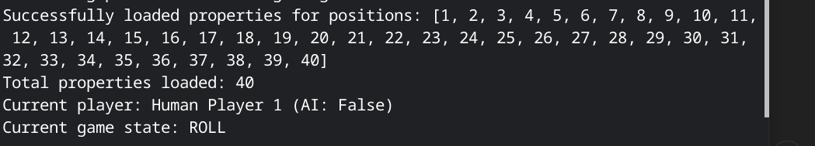 | Pass | No action needed | The test bank limit is £50,000
2 | Dice Rolling and Movement | Click the "Roll" button during the player's turn | Dice animation should display random values 1-6, and the player token should move the correct number of spaces | dice animation is working and stops in a few seconds | 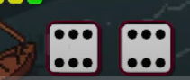 | Pass | No action needed | Check double rolls logic
3 | Player Passing GO | Move the player across the GO space | The player should receive £200, lap counter should increment | The player should receive £200, and be able to buy the property after passing go on the first time | 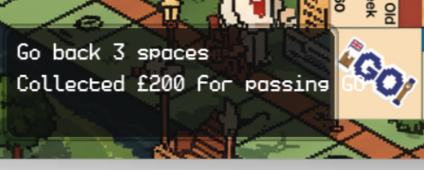 | Pass | No action needed | /
4 | Property Purchase | Land on unowned property, click the "Buy" button | Player money should decrease by property price, property should show ownership | show ownership on the player card with a colour box | 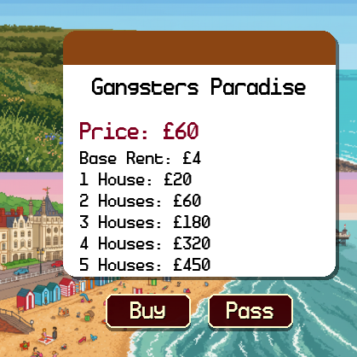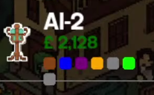 | Pass | No action needed | Test with different property types
5 | Rent Payment | Land on property owned by another player | Correct rent should be calculated and transferred from the landing player to the owner. | Rent paid successfully |  | Pass | No action needed | Test different rent scenarios
6 | Auction System | Decline to purchase property when landing on it | An auction interface should appear, and all players should be able to bid | yes, works, but not for players in jail | 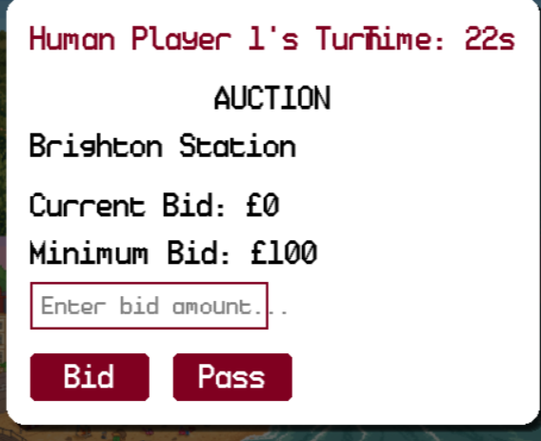 | Pass | No action needed | Test AI bidding behaviour
7 | Card Drawing | Land on "Pot Luck" or "Opportunity Knocks" spaces | A card should be drawn and its effect applied to the player |  | 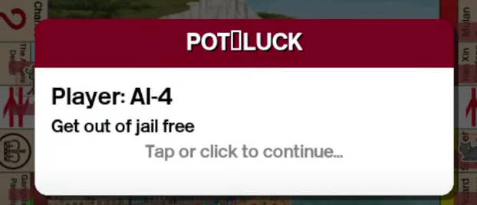 |  |  | Check all card types
8 | Jail Mechanics | Roll three consecutive doubles or land on "Go to Jail" | The player should move to jail, miss turns until conditions meet | working, player position move to jail | 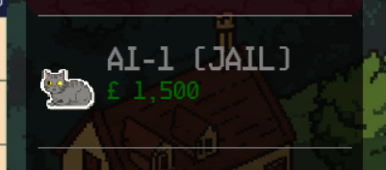 | Pass | No action needed | Test all jail escape options
9 | Free Parking | Land on Free Parking space | The player should collect accumulated fine money (if the house rule is enabled) | working, the total amount of free parking space has been showing on the UI | 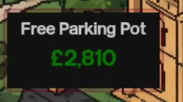 | Pass | No action needed | Optional house rule
10 | House Building | Select a property from a complete set, click "Build House" | House should be added to the property, rent values should increase | House added and showed on player card and the board ui | 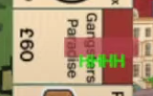 | Pass | No action needed | Test after the first lap
11 | Bankruptcy Handling | Force players to pay more money than they have | The player should go bankrupt, and assets transferred to the bank | the player was marked as bankrupt |  | Pass | No action needed | fixed:
12 | AI Player Turn Processing | Wait for the AI player to turn | AI should make decisions based on difficulty level | working | 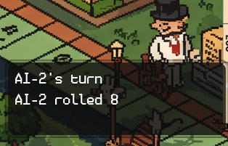 | Pass | No action needed | Tests are both easy and hard difficulty
13 | Game End Condition | Play until only one player remains solvent | The game should end and declare winner | show end game screen | 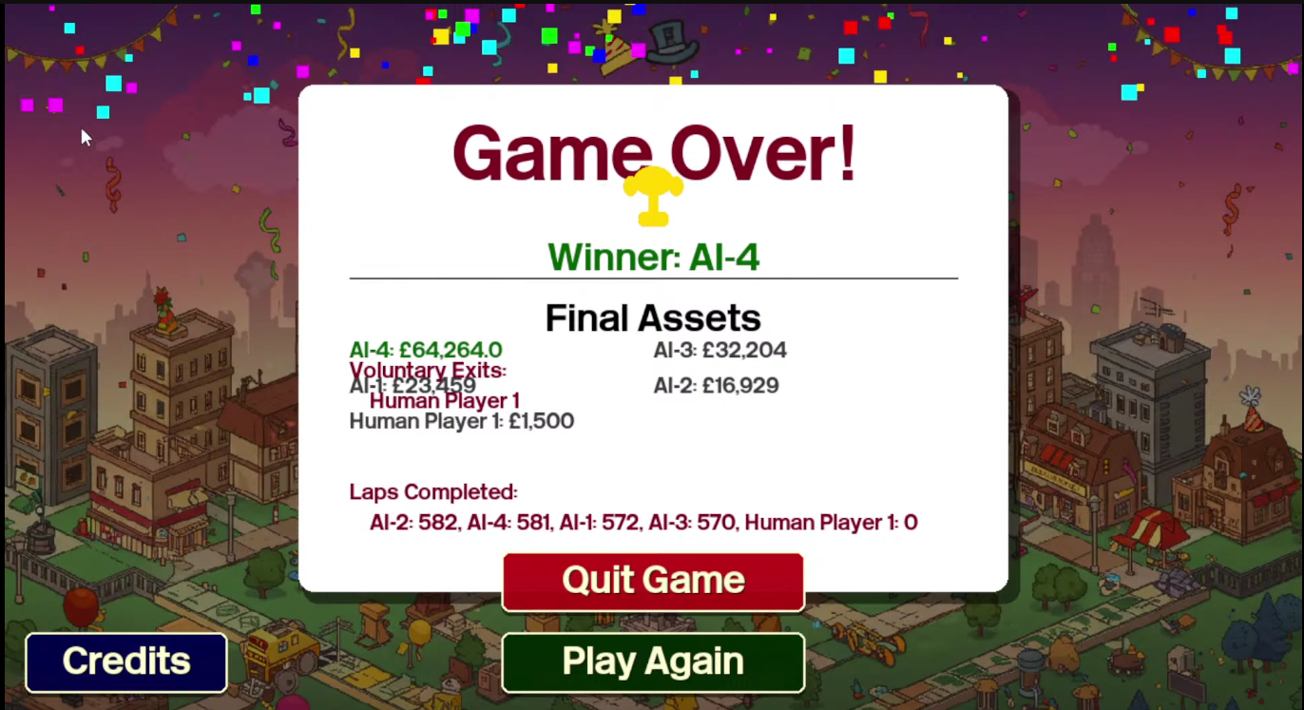 | Pass | No action needed | Check winner calculation
14 | Time Limit (Abridged Game) | Play abridged game mode for set time | Games should end after time expires | show end game screen | 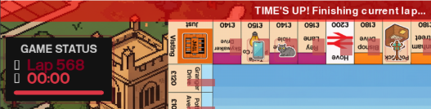 | Pass | No action needed | 180min max

